Electric Circuits II Project Report

Prepared by

Name | ID
Mariam Boulos | 61-1773
Azza Darwish | 61-1508
Farial Abdelrahem Boraei | 61-16271

Tutorial Number: 14

Theoretical background:

Band Stop filter circuit 4 (Basic wideband Band stop filter):

A band-stop filter attenuates signals within a specific frequency range called the stopband while allowing frequencies outside this range to pass with minimal attenuation. For frequencies outside the stopband, the gain is ideally 1 (0 dB).
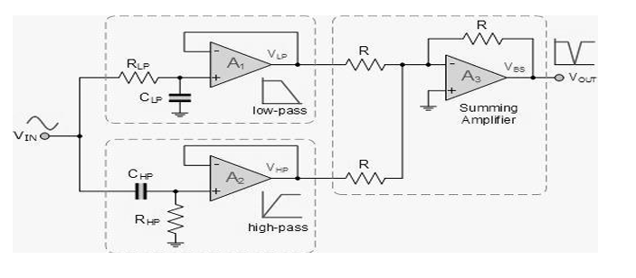

The circuit consists of three main sections:
- Low-Pass Filter:
- Components: RLp, CLp
- Defines the upper limit of the low-pass section, allowing signals below the frequency to pass
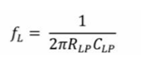

- RLp: Resistor for low pass.
- CLp: Capacitor for low pass.
- High-Pass Filter:
- Components: RHp, CHp
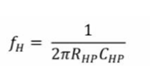
- Defines the lower limit of the low-pass section, allowing signals above the frequency to pass.

- RHp: Resistor for high pass.
- CHp: Capacitor for low pass.

- Summing amplifier:
- Combines the outputs of both filters
- Attenuates frequencies between fL and fH

Key Equations
  - Stopband Width:
- The range between fL and fH defines the rejected frequency band.

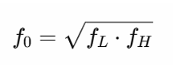
  - Center Frequency (f0):

  - Cut off Frequency:
- A specific frequency point where a circuit starts to attenuate the intensity of the signal

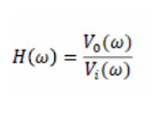
  - Gain:

Filter design:
Component Section:
  - Low-Pass Section (sets f_L =1.+59kHz):
- R_Lp = 10kΩ
- C Lp = 10nF
  - High-Pass Section (sets f_H =15.9kHz):
- R_HP = 10kΩ
- C_HP = 1nF

  - Summing Amplifier:
- Gain resistors (R) = 10k Ω each.
- Feedback resistor (R) = 10k Ω for unity gain.


  - Center Frequency f0:
- f0= 5.028kHz
- fL= 1.59kHz
- fH= 15.9kHz

Simulation results:
Provide the screenshots for the obtained simulation results and comments on the simulation results.
You need to run two simulation profiles:

AC sweep simulation:
to sketch the gain versus the frequency, where Vac is used as the input signal (One sketch is required).
NB: when you acquire the results from the AC Sweep, you should make sure the gain is ≥ 1
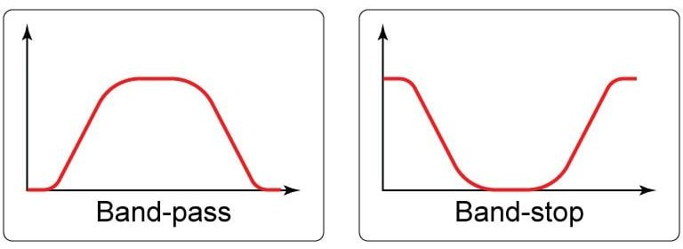
𝑉𝑜𝑢𝑡
Figure 1 Expected outcome for the AC Sweep

Time domain simulation:
to sketch voltage amplitude versus time, where Vsin is used as the input signal at three different frequencies (f < fo , f = fo and f > fo) (three sketches are required).

Circuit simulation:

The circuit was constructed using PSpice with the following components:
- 3 Op-Amp: LM741 from Eval library.
- 5 Resistors: 10 kΩ from library Analog library.
- Vin (f= 1k\ 8k \ 100k, amp = 2V, Voff \ Vac= 0V) (Time Domain) from Source library.
- Vac (1V) (Ac Sweep) from Source library.
- Capacitors: 10 nF (low-pass), 1 nF (high-pass) from Analog library.
- 6 Vdc (-10V & +10V) from Source library.
- 10 Ground (0) from Source library.

AC Sweep Profile:

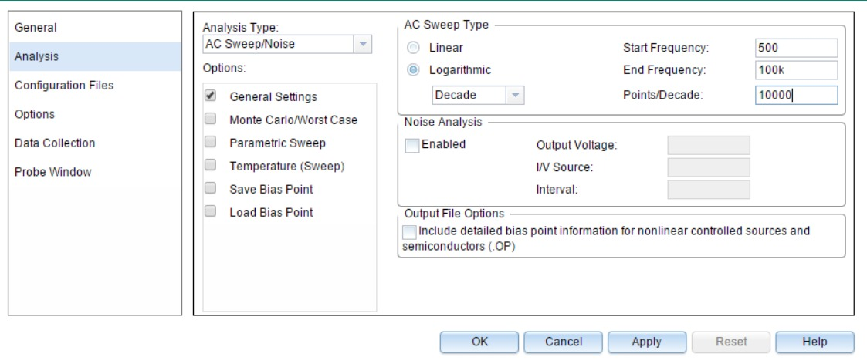

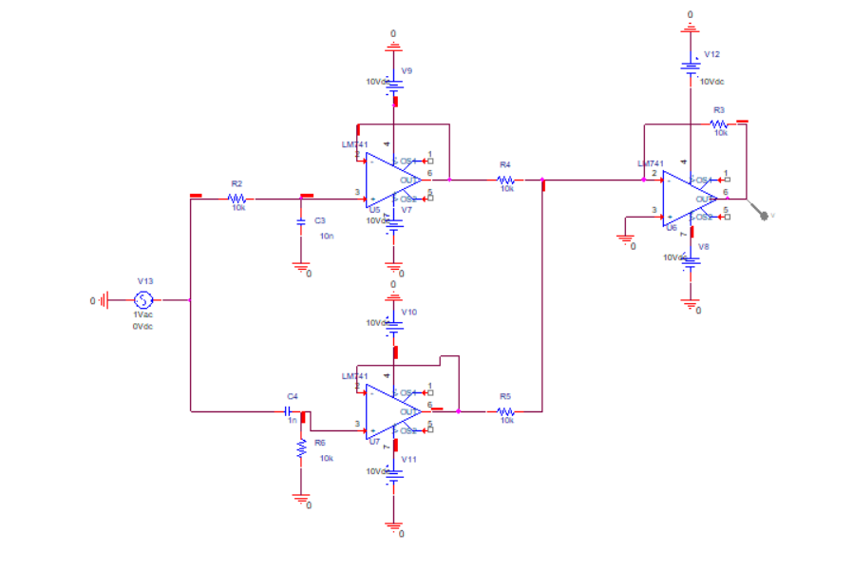
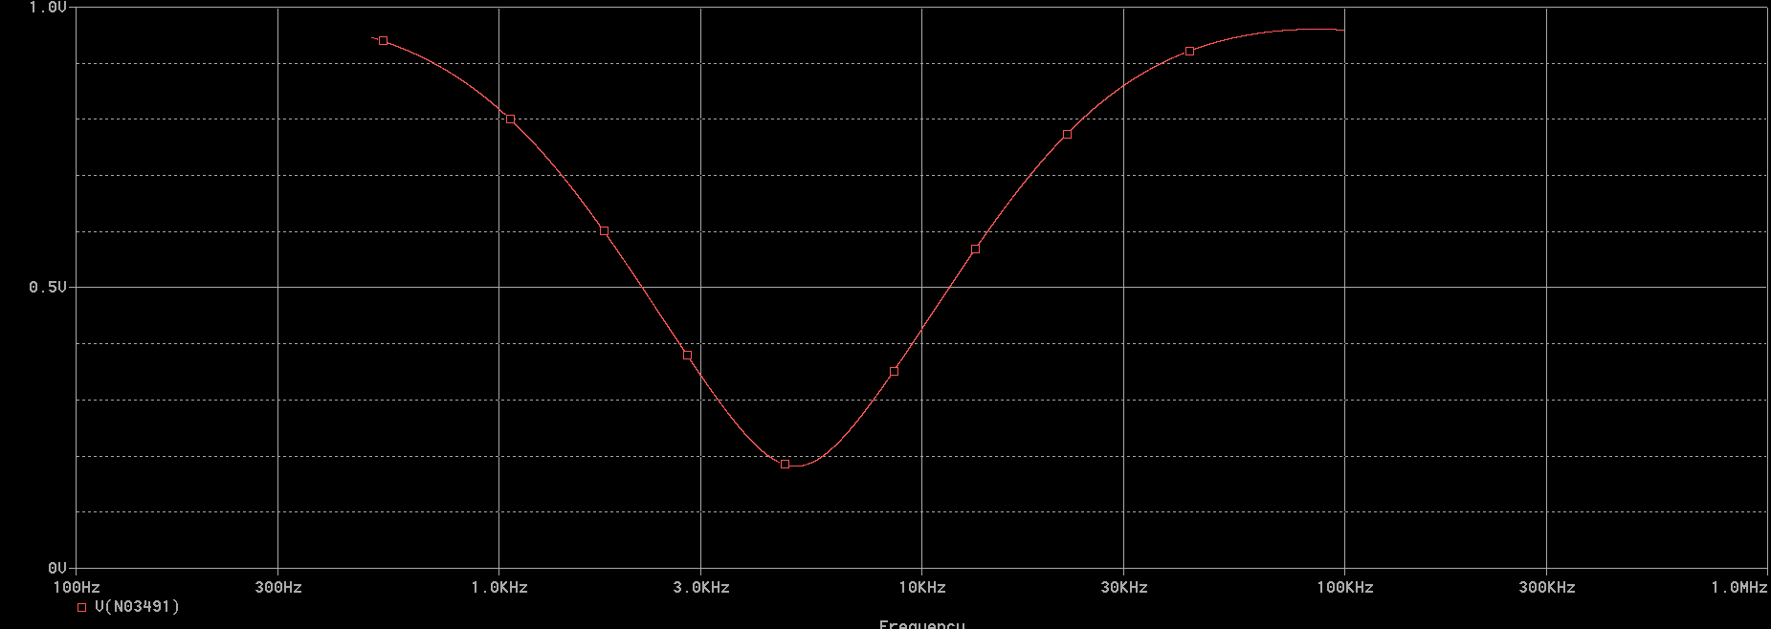
AC Sweep
Gain= 0.95

Time Domain Profile:
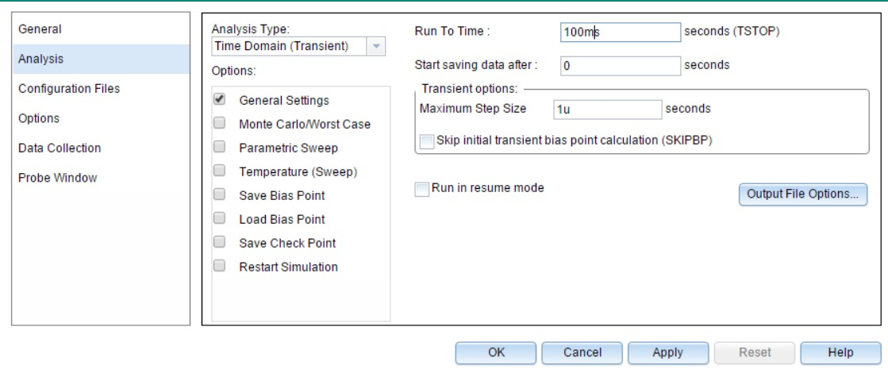

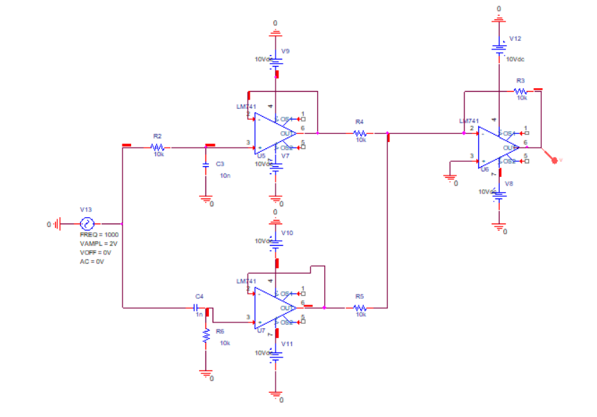
Time Domain

fL > f (f=1kHz) (the output is accurate because it is outside the range and circuit is band stop) V= 1.6V
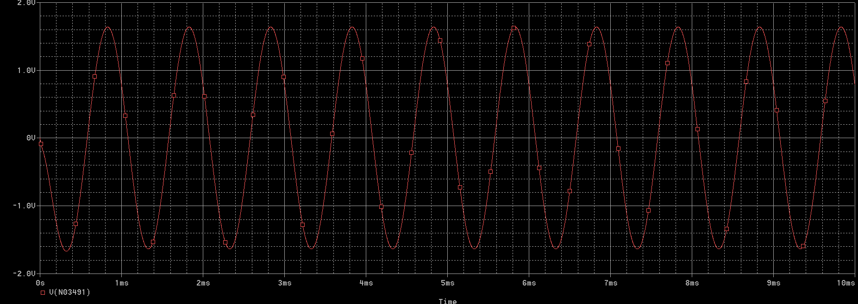

fH > f and fL < f (f= 8.75kHz) (the output is accurate because it is inside the range and circuit is band stop, therefore voltage decreased) V= 0 .68V
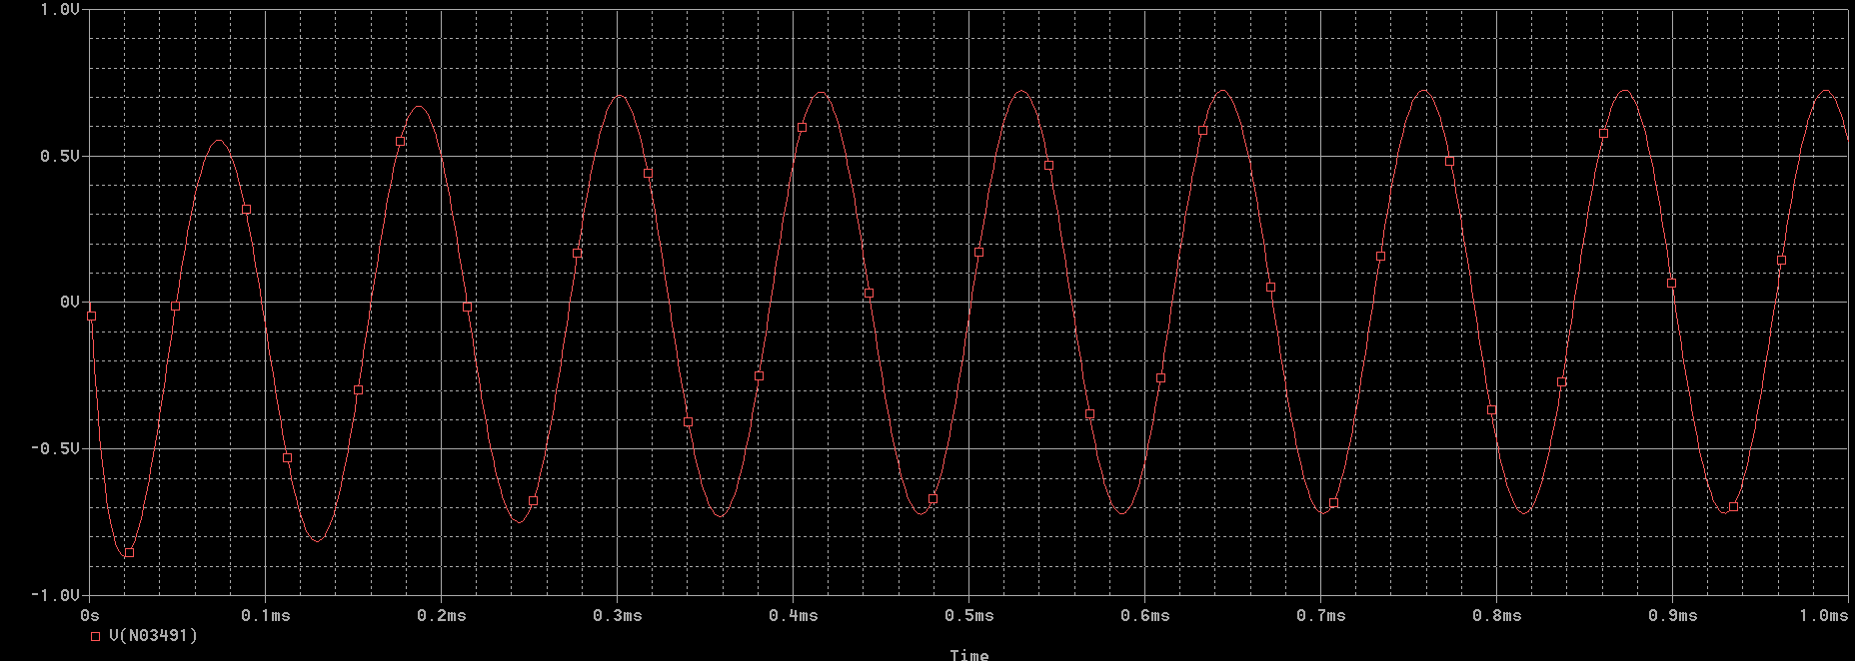

fH < f (f= 100kHz) (the output is accurate because it is outside the range and circuit is band stop) V= 1V
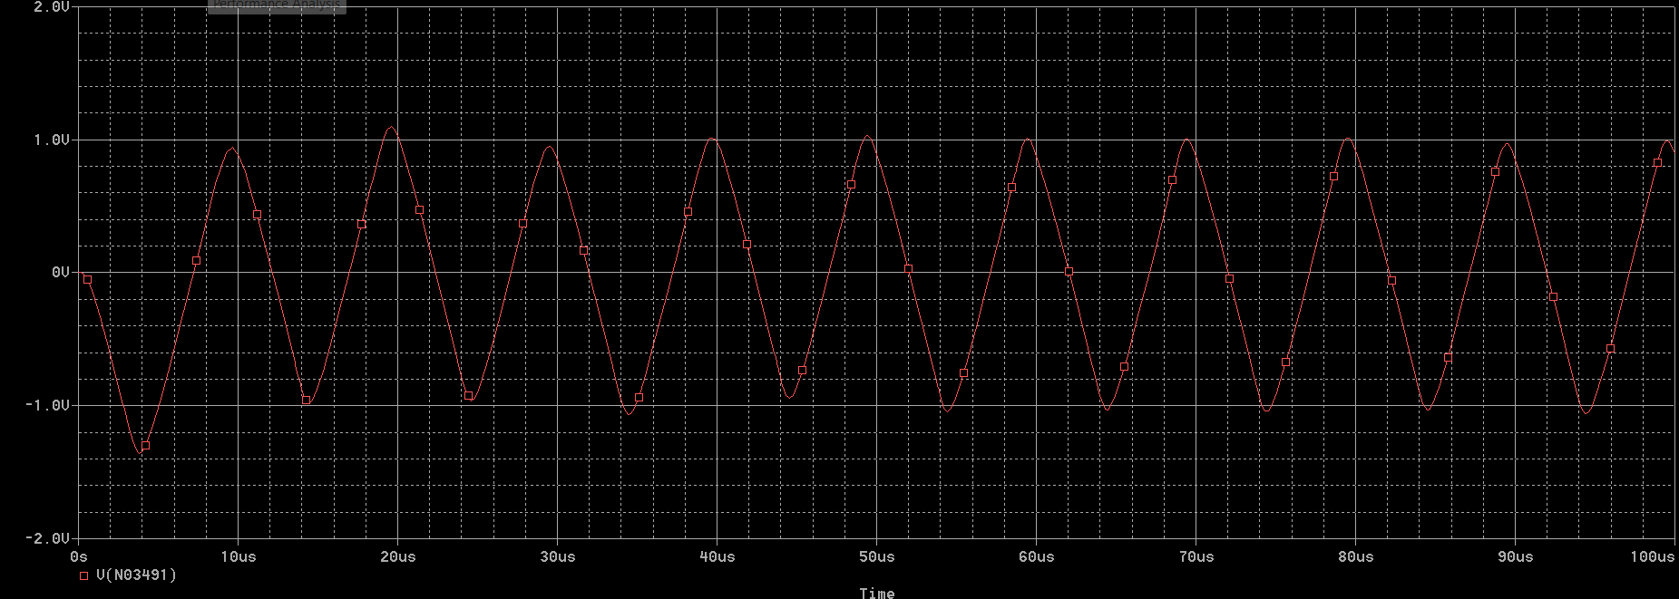

Hardware implementation:
This should include the details of the purchased components and pictures for the hardware implementation of the filter circuit.
Hardware implementation of the filter circuit:
Components Used:
- 3 Op-Amp: LM741
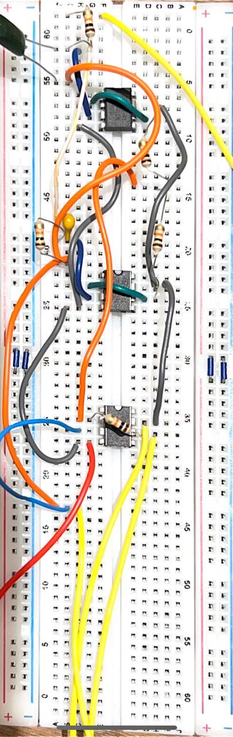
- 5 Resistors: 10kΩ
- Capacitors: 10 nF (low-pass), 1 nF (high-pass)
- Breadboard and connecting wires
Circuit implementation:

Hardware results:
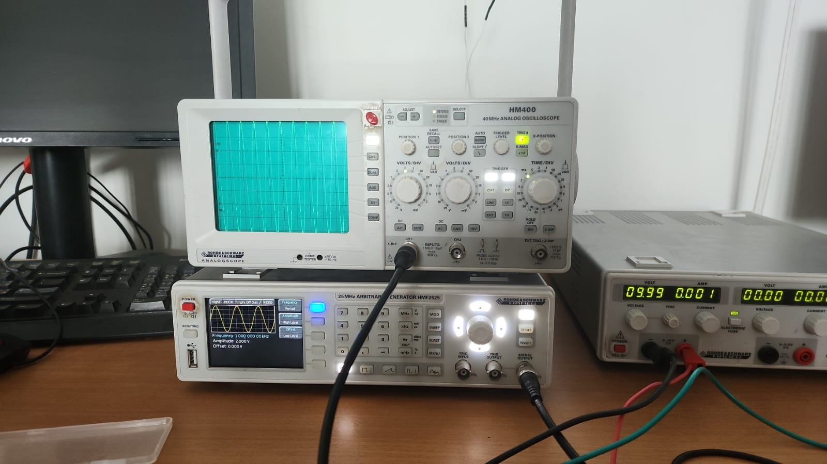

𝒇 < 𝒇𝒐:
For input signals with frequencies lower than f₀, the filter operates in its passband, allowing the signal to pass through with minimal alteration. The oscilloscope displays input and output waveforms that are virtually indistinguishable in terms of amplitude and phase.

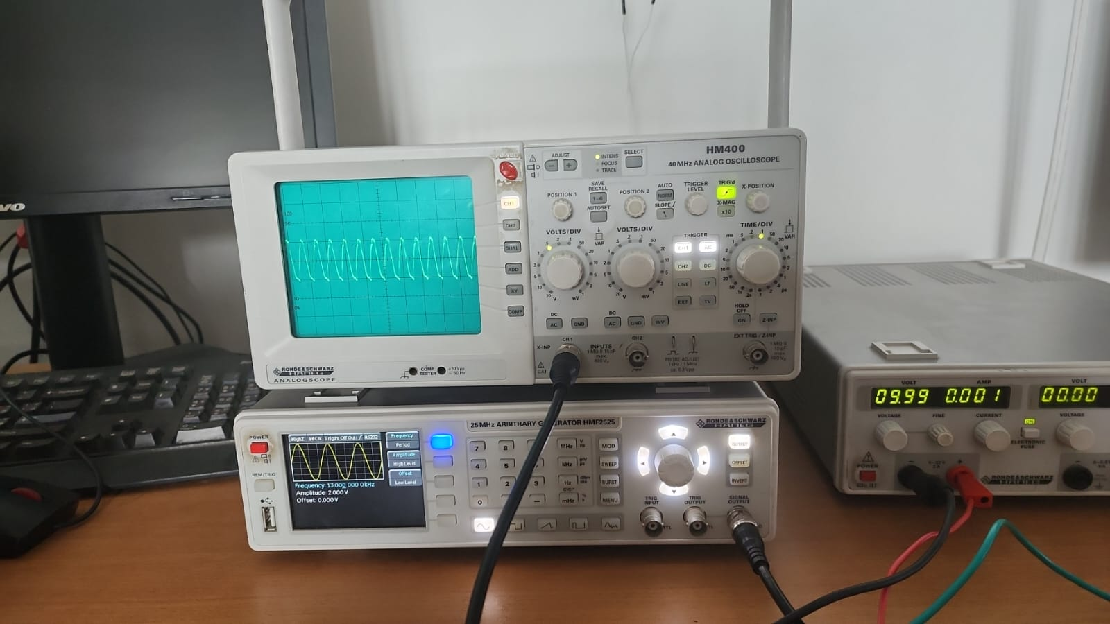

𝒇 = 𝒇𝒐:
At the center frequency, the filter operates in its stopband region. This results in severe attenuation of the output signal, which appears drastically reduced or nearly flat when viewed on the oscilloscope relative to the input.

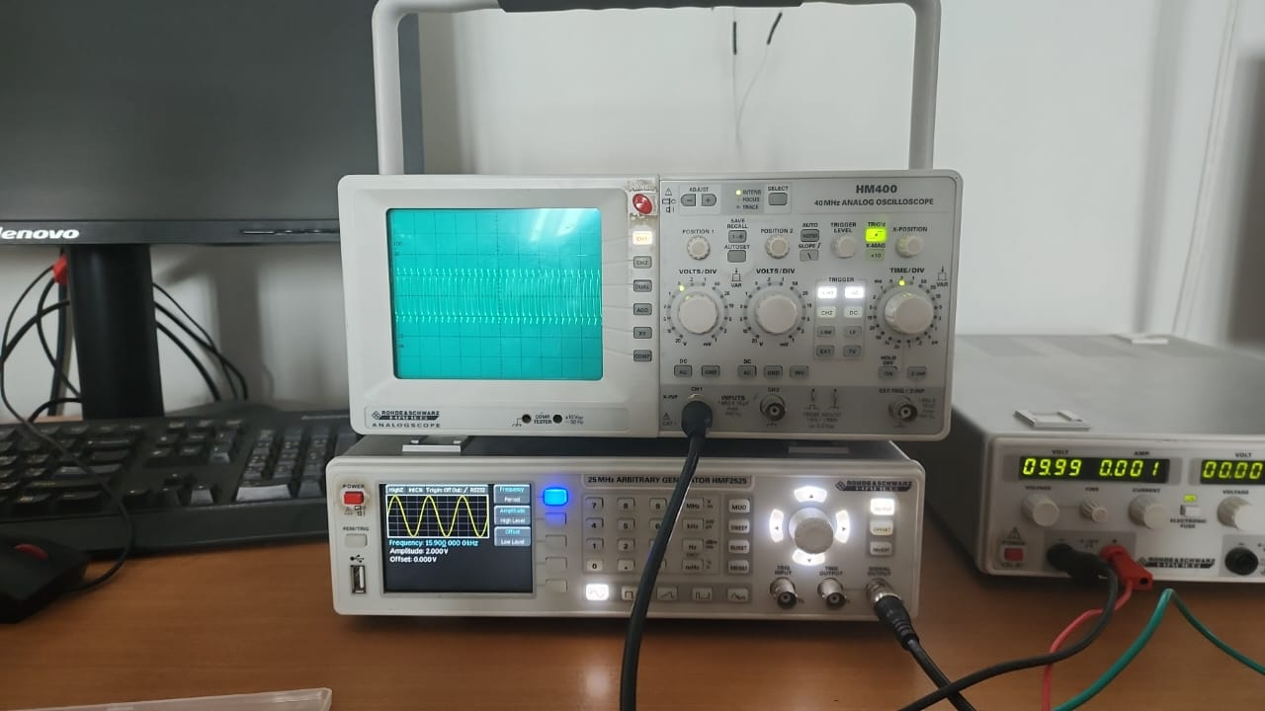

𝒇 > 𝒇𝒐:
For frequencies above the center frequency (f₀), the filter's passband behavior resumes, with the oscilloscope displaying output signal amplitude like the input.

